Registration form
 |  | Faculty Development Programme on  Financial Statistics  (December 20-22, 2017)  Website: http://statistics.du.ac.in Phone: 91-11-27666671 |  |  | 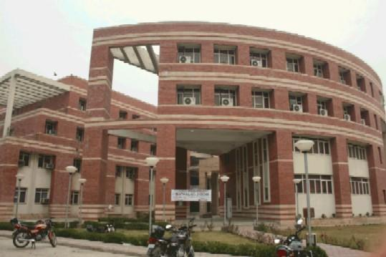
Photo
Photo

 | Name of the participant |  | : | ………………………………………………………….
 | Sex |  | : | - Male (b) Female
 | Designation |  | : | ………………………………………………………….
 | Qualification |  | : | NET :  M.Phil. : Pursuing Completed  Ph.D. : Pursuing Completed
 | Department |  | : | …………………………………………………………..
 | Institute/Organization |  | : | …………………………………………………………..
 | Address |  | : | …………………………………………………………..  ………………………………………………………….
 | Mobile Number |  | : | ………………………………………………………….
 | E-mail |  | : | ………………………………………………………….
 | Area of Interest |  | : | …………………………………………………………..
Date |  |  | : | ………………………………………………………….
Place |  |  | : | …………………………………………………………..
 |  |  |  | Signature of Participant

- Note: Apply online by sending duly signed registration form without fee to statsfdp@gmail.com latest by December 18, 2017, 12.00 noon.

